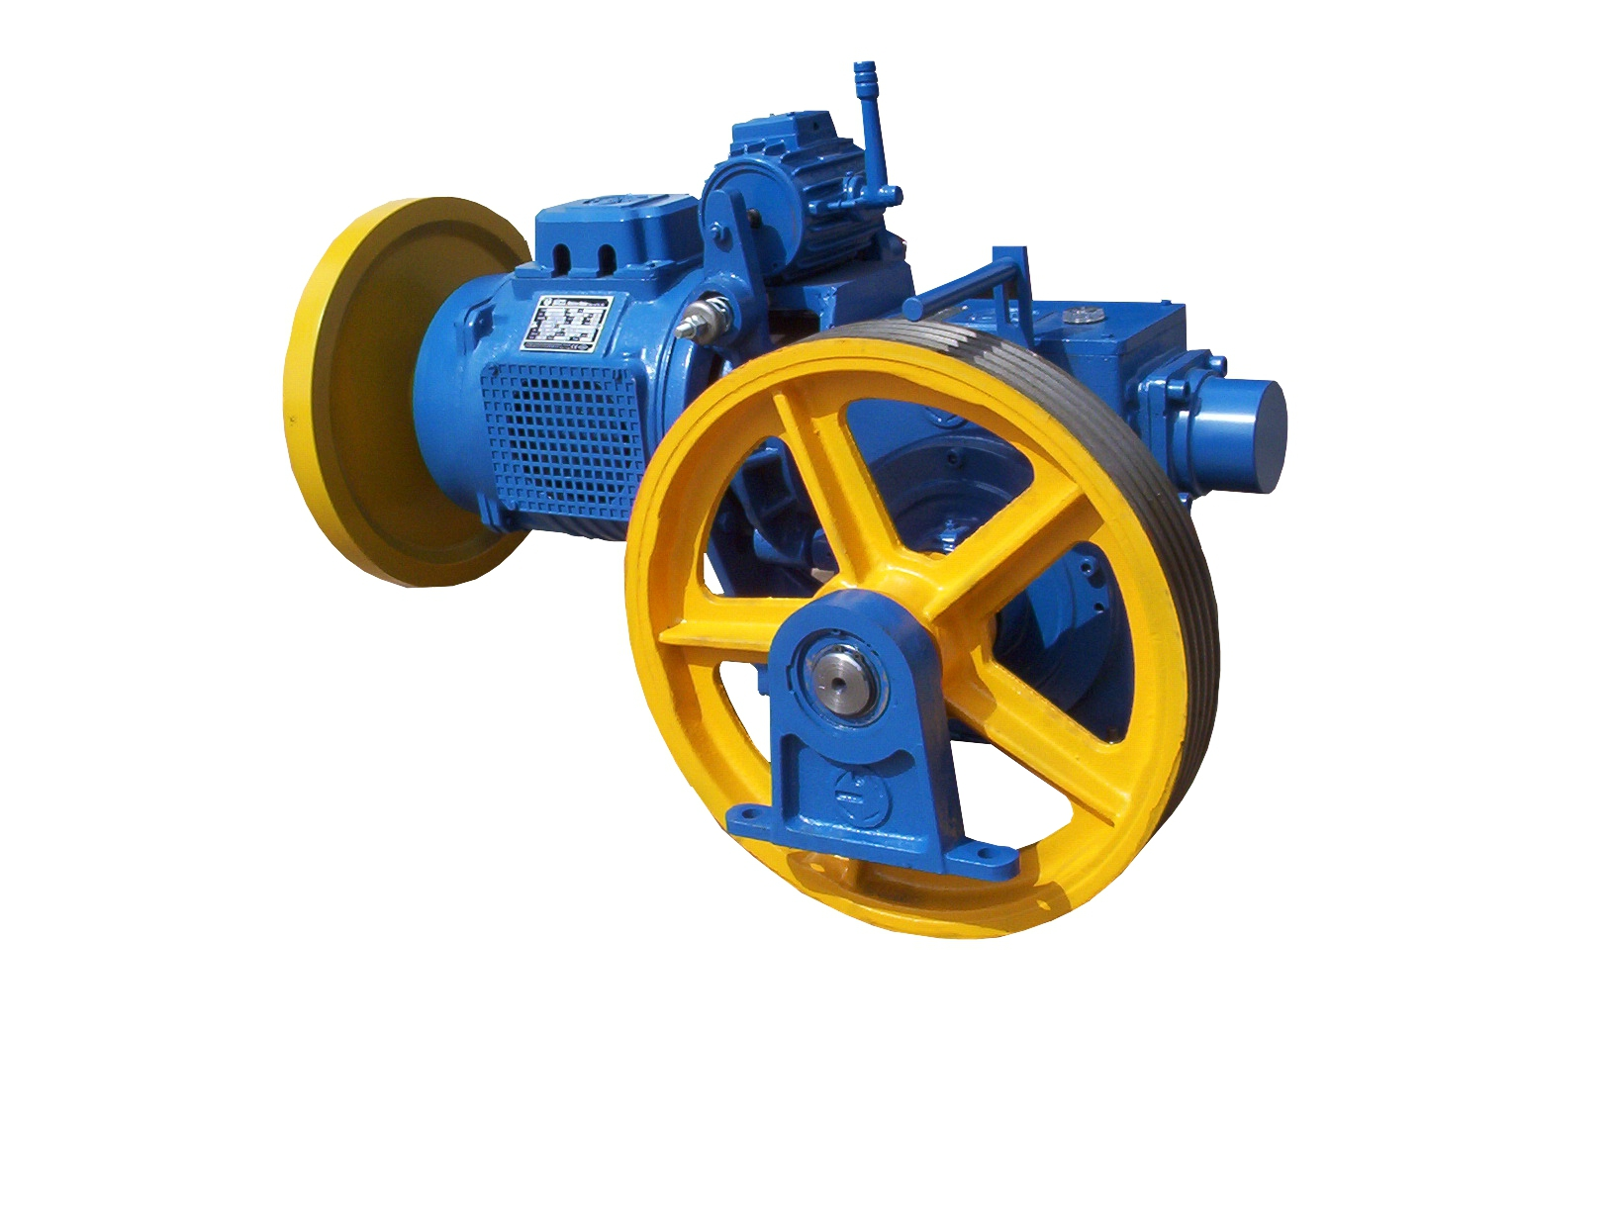**YC125**



|  |  |  |  |  |  |  |  |  |  |
| --- | --- | --- | --- | --- | --- | --- | --- | --- | --- |
| **Sıra**  *Item Nr* | **Kapasite**  *Load* | **Motor**  *Motor* | **Motor Hızı**  *Motor Speed* | **Oran**  *Ratio* | **Askı**  *Ropping* | **Kasnak Çapı**  *Sheave Dia* | **Kabin Hızı**  *Car Speed* | **Motor Gücü**  *Motor Power* | |
| 1 | 320 kg | AC2 | 1.450 rpm | 1 : 41 | 1 : 1 | Ø520 mm | 1,00 m/s | 4,0 kW | 5,5 HP |
| 2 | 320 kg | AC2 | 1.450 rpm | 2 : 52 | 1 : 1 | Ø450 mm | 1,20 m/s | 5,0 kW | 6,8 HP |
| 3 | 450 kg | AC2 | 1.450 rpm | 2 : 52 | 1 : 1 | Ø450 mm | 1,20 m/s | 5,9 kW | 8,0 HP |